1.Create a HTML page with Java Script (built in functions-(date, display, create date object etc.), user defined Functions- (passing parameter, recursive function))

<!DOCTYPE html>

<html lang="en">

<head>

<meta charset="UTF-8">

<meta name="viewport" content="width=device-width, initial-scale=1.0">

<title>Date and Recursive Function Example</title>

<script>

function displayCurrentDateTime() {

let currentDate = new Date();

let dateTimeString = currentDate.toLocaleString();

document.getElementById("datetime").innerText = dateTimeString;

}

function factorial(n) {

if (n === 0 || n === 1) {

return 1;

} else {

return n * factorial(n - 1);

}

}

function calculateFactorial() {

let num = parseInt(document.getElementById("numInput").value);

let result = factorial(num);

document.getElementById("factorialResult").innerText = `Factorial of ${num} is ${result}`;

}

</script>

</head>

<body>

<h1>Date and Recursive Function Example</h1>

<p>Click the button below to display the current date and time:</p>

<button onclick="displayCurrentDateTime()">Display Date and Time</button>

<p id="datetime"></p>

<hr>

<h2>Factorial Calculation</h2>

<p>Enter a number to calculate its factorial:</p>

<form onsubmit="event.preventDefault(); calculateFactorial();">

<input type="number" id="numInput" required>

<button type="submit">Calculate Factorial</button>

</form>

<p id="factorialResult"></p>

</body>

</html>

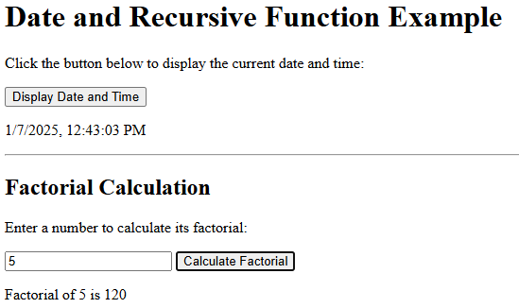

2: Create simple JavaScript programs.(Add two numbers, Factorial of a given no , Check if a string is palindrome or not)

<!DOCTYPE html>

<html lang="en">

<head>

<meta charset="UTF-8">

<meta name="viewport" content="width=device-width, initial-scale=1.0">

<title>Add Two Numbers - JavaScript</title>

<script>

function addNumbers() {

let num1 = parseInt(document.getElementById("num1").value);

let num2 = parseInt(document.getElementById("num2").value);

let sum = num1 + num2;

document.getElementById("result").innerText = `Sum: ${sum}`;

}

</script>

</head>

<body>

<h2>Add Two Numbers</h2>

<label for="num1">Number 1:</label>

<input type="number" id="num1"><br><br>

<label for="num2">Number 2:</label>

<input type="number" id="num2"><br><br>

<button onclick="addNumbers()">Add</button><br><br>

<p id="result"></p>

</body>

</html>

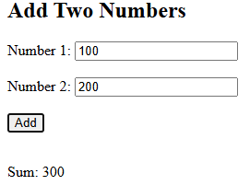

<!DOCTYPE html>

<html lang="en">

<head>

<meta charset="UTF-8">

<meta name="viewport" content="width=device-width, initial-scale=1.0">

<title>Factorial of a Number - JavaScript</title>

<script>

function calculateFactorial() {

let num = parseInt(document.getElementById("num").value);

let result = factorial(num);

document.getElementById("result").innerText = `Factorial of ${num} is ${result}`;

}

function factorial(n) {

if (n === 0 || n === 1) {

return 1;

} else {

return n * factorial(n - 1);

}

}

</script>

</head>

<body>

<h2>Factorial of a Number</h2>

<label for="num">Enter a number:</label>

<input type="number" id="num"><br><br>

<button onclick="calculateFactorial()">Calculate Factorial</button><br><br>

<p id="result"></p>

</body>

</html>

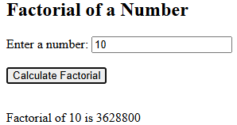

3. Check if a String is Palindrome (JavaScript)

<!DOCTYPE html>

<html lang="en">

<head>

<meta charset="UTF-8">

<meta name="viewport" content="width=device-width, initial-scale=1.0">

<title>Palindrome Check - JavaScript</title>

<script>

function checkPalindrome() {

let inputString = document.getElementById("inputString").value;

let result = isPalindrome(inputString);

if (result) {

document.getElementById("result").innerText = `${inputString} is a palindrome.`;

} else {

document.getElementById("result").innerText = `${inputString} is not a palindrome.`;

}

}

function isPalindrome(str) {

str = str.toLowerCase().replace(/[^a-zA-Z0-9]/g, ''); // Remove non-alphanumeric characters and convert to lowercase

let len = str.length;

for (let i = 0; i < len/2; i++) {

if (str[i] !== str[len - 1 - i]) {

return false;

}

}

return true;

}

</script>

</head>

<body>

<h2>Palindrome Check</h2>

<label for="inputString">Enter a string:</label>

<input type="text" id="inputString"><br><br>

<button onclick="checkPalindrome()">Check Palindrome</button><br><br>

<p id="result"></p>

</body>

</html>

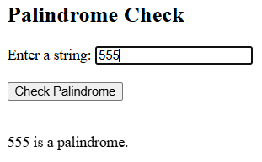

3: Write a PHP program to demonstrate simple tasks (such as: to display ‘hello’) and basic PHP syntax (includes defining variable, constant, data type and basic arithmetic Operations with operators) .

<!DOCTYPE html>

<html lang="en">

<head>

<meta charset="UTF-8">

<title>PHP Simple Tasks and Syntax</title>

</head>

<body>

<h1>PHP Simple Tasks and Syntax</h1>

<?php

echo "<p>Hello, World!</p>";

$name = "Debasish Barman";

$age = 21;

$height = 171;

$isStudent = true;

echo "<p>Name: " . $name . "</p>";

echo "<p>Age: " . $age . "</p>";

echo "<p>Height: " . $height . " cm</p>";

echo "<p>Is Student: " . ($isStudent ? 'Yes' : 'No') . "</p>";

define('PI', 3.14159);

define('GREETING', 'Welcome to PHP!');

echo "<p>Value of PI: " . PI . "</p>";

echo "<p>Greeting Message: " . GREETING . "</p>";

$num1 = 10;

$num2 = 5;

echo "<h2>Arithmetic Operations</h2>";

echo "<p>Addition: " . ($num1 + $num2) . "</p>";

echo "<p>Subtraction: " . ($num1 - $num2) . "</p>";

echo "<p>Multiplication: " . ($num1 * $num2) . "</p>";

echo "<p>Division: " . ($num1 / $num2) . "</p>";

echo "<p>Modulus: " . ($num1 % $num2) . "</p>";

?>

</body>

</html>

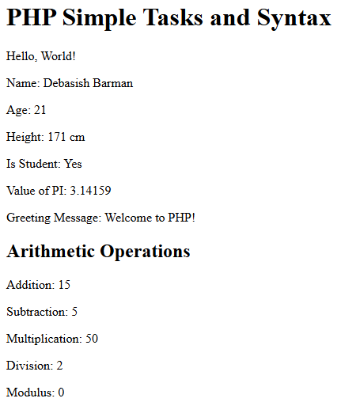

4.Write a PHP program to demonstrate condition/decision making and loop statement

<!DOCTYPE html>

<html lang="en">

<head>

<meta charset="UTF-8">

<title>PHP Condition and Loop Statements</title>

</head>

<body>

<h1>PHP Condition and Loop Statements</h1>

<?php

$num = 15;

echo "<h2>Condition/Decision Making</h2>";

if ($num > 10) {

echo "<p>$num is greater than 10.</p>";

} elseif ($num == 10) {

echo "<p>$num is equal to 10.</p>";

} else {

echo "<p>$num is less than 10.</p>";

}

echo "<h2>Loop Statements</h2>";

echo "<h3>While Loop:</h3>";

$i = 1;

while ($i <= 5) {

echo "Iteration $i<br>";

$i++;

}

echo "<h3>For Loop:</h3>";

for ($j = 1; $j <= 5; $j++) {

echo "Iteration $j<br>";

}

echo "<h3>Do-While Loop:</h3>";

$k = 1;

do {

echo "Iteration $k<br>";

$k++;

} while ($k <= 5);

?>

</body>

</html>

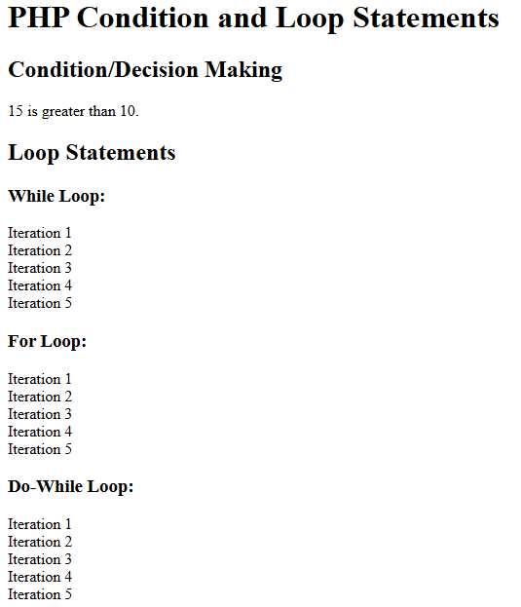

5: Write a PHP program to demonstrate mixing of decisions and looping statements with HTML script.

<!DOCTYPE html>

<html lang="en">

<head>

<meta charset="UTF-8">

<title>PHP Mixing Decisions and Looping with HTML</title>

<style>

.odd {

background-color: #f0f0f0;

}

.even {

background-color: #cccccc;

}

</style>

</head>

<body>

<h1>PHP Mixing Decisions and Looping with HTML</h1>

<?php

$numbers = [1, 2, 3, 4, 5];

foreach ($numbers as $num) {

if ($num % 2 == 0) {

$class = 'even';

} else {

$class = 'odd';

}

echo "<div class=\"$class\">Number: $num</div>";

}

?>

</body>

</html>

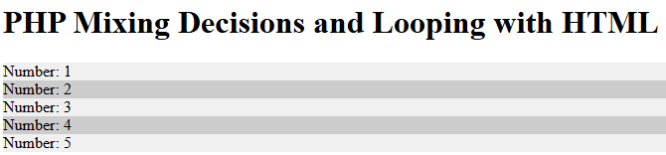

6: Write a PHP program to demonstrate call by value, call by reference and recursive function.

<!DOCTYPE html>

<html lang="en">

<head>

<meta charset="UTF-8">

<title>PHP Call by Value, Call by Reference, Recursive Function</title>

</head>

<body>

<h1>PHP Call by Value, Call by Reference, Recursive Function</h1>

<?php

function incrementByValue($num) {

$num += 10;

echo "<p>Inside incrementByValue function: \$num = $num</p>";

}

$value = 5;

echo "<p>Before calling incrementByValue function: \$value = $value</p>";

incrementByValue($value);

echo "<p>After calling incrementByValue function: \$value = $value</p>"; // $value remains unchanged

function incrementByReference(&$num) {

$num += 10;

echo "<p>Inside incrementByReference function: \$num = $num</p>";

}

$value = 5;

echo "<p>Before calling incrementByReference function: \$value = $value</p>";

incrementByReference($value);

echo "<p>After calling incrementByReference function: \$value = $value</p>"; // $value is modified

function factorial($n) {

if ($n <= 1) {

return 1;

} else {

return $n * factorial($n - 1);

}

}

$num = 5;

echo "<p>Factorial of $num is " . factorial($num) . "</p>";

?>

</body>

</html>

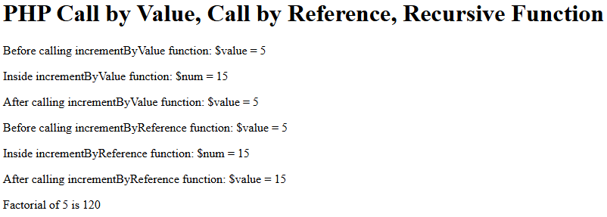

7.Write a PHP Program for String Creating and accessing, String Searching & Replacing String, Formatting String and demonstrating String Related Library function.

<!DOCTYPE html>

<html lang="en">

<head>

<meta charset="UTF-8">

<title>PHP String Operations</title>

</head>

<body>

<h1>PHP String Operations</h1>

<?php

$str1 = "Hello, World!";

$str2 = 'PHP is awesome!';

echo "<h2>Creating and Accessing Strings</h2>";

echo "<p>String 1: $str1</p>";

echo "<p>String 2: $str2</p>";

$len1 = strlen($str1);

$len2 = strlen($str2);

echo "<p>Length of String 1: $len1</p>";

echo "<p>Length of String 2: $len2</p>";

$concatenatedStr = $str1 . ' ' . $str2;

echo "<p>Concatenated String: $concatenatedStr</p>";

$searchStr = "PHP";

$replaceStr = "JavaScript";

$newStr = str_replace($searchStr, $replaceStr, $concatenatedStr);

echo "<h2>String Searching and Replacing</h2>";

echo "<p>Original String: $concatenatedStr</p>";

echo "<p>After replacing '$searchStr' with '$replaceStr': $newStr</p>";

$price = 49.99;

echo "<h2>Formatting Strings</h2>";

echo "<p>Price: $" . number_format($price, 2) . "</p>";

echo "<h2>String Related Library Functions</h2>";

$uppercaseStr = strtoupper($str1);

$lowercaseStr = strtolower($str2);

echo "<p>Uppercase of '$str1': $uppercaseStr</p>";

echo "<p>Lowercase of '$str2': $lowercaseStr</p>";

$strWithWhitespace = " Trim Test ";

$trimmedStr = trim($strWithWhitespace);

echo "<p>Original String with whitespace: '$strWithWhitespace'</p>";

echo "<p>Trimmed String: '$trimmedStr'</p>";

$searchSubstring = "World";

$pos = strpos($str1, $searchSubstring);

if ($pos !== false) {

echo "<p>Position of '$searchSubstring' in '$str1': $pos</p>";

} else {

echo "<p>'$searchSubstring' not found in '$str1'</p>";

}

$repeatStr = str_repeat('PHP ', 3);

echo "<p>Repeated String: $repeatStr</p>";

?>

</body>

</html>

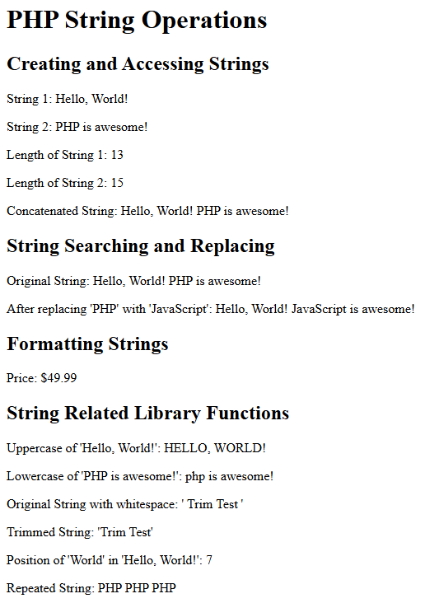

8: Write a PHP program for creating index based and associative arrays. Also demonstrate accessing the array and element looping with Index based array

<!DOCTYPE html>

<html lang="en">

<head>

<meta charset="UTF-8">

<title>PHP Arrays</title>

</head>

<body>

<h1>PHP Arrays</h1>

<?php

$indexArray = array("Apple", "Banana", "Cherry", "Date", "Fig");

$assocArray = array(

"fruit1" => "Apple",

"fruit2" => "Banana",

"fruit3" => "Cherry",

"fruit4" => "Date",

"fruit5" => "Fig"

);

echo "<h2>Accessing Index Based Array</h2>";

echo "<p>First element: " . $indexArray[0] . "</p>";

echo "<p>Third element: " . $indexArray[2] . "</p>";

echo "<h2>Looping through Index Based Array</h2>";

echo "<ul>";

foreach ($indexArray as $fruit) {

echo "<li>$fruit</li>";

}

echo "</ul>";

?>

</body>

</html>

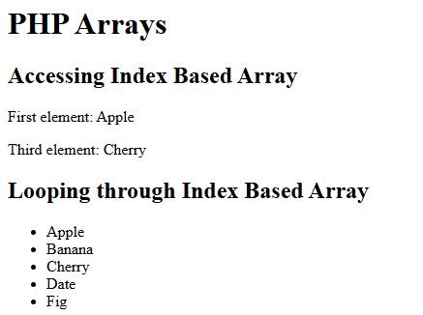

9: Write a PHP Program to demonstrate associative arrays using each () and for each() and a few related Library functions. Enhance the array program by including decision and loop statements.

<!DOCTYPE html>

<html lang="en">

<head>

<meta charset="UTF-8">

<title>PHP Associative Arrays and Functions</title>

</head>

<body>

<h1>PHP Associative Arrays and Functions</h1>

<?php

$studentScores = array(

"Debasish" => 85,

"Sayan" => 92,

"Srijit" => 78,

"Subhadeep" => 88,

"Rounak" => 95

);

echo "<h2>Demonstrating each() Function</h2>";

reset($studentScores); // Resetting array pointer

while ($pair = each($studentScores)) {

echo "<p>{$pair['key']} scored {$pair['value']} marks.</p>";

}

echo "<h2>Demonstrating foreach() Loop</h2>";

foreach ($studentScores as $name => $score) {

echo "<p>$name scored $score marks.</p>";

}

echo "<h2>Using Library Functions</h2>";

$numStudents = count($studentScores);

echo "<p>Number of students: $numStudents</p>";

$keyToCheck = "Doe";

if (array_key_exists($keyToCheck, $studentScores)) {

echo "<p>$keyToCheck exists in the array.</p>";

} else {

echo "<p>$keyToCheck does not exist in the array.</p>";

}

$maxScore = max($studentScores);

echo "<p>Maximum score: $maxScore</p>";

$totalScore = array_sum($studentScores);

$averageScore = $totalScore / $numStudents;

echo "<p>Average score: " . round($averageScore, 2) . "</p>";

echo "<h2>Using Decision and Loop Statements</h2>";

$passingScore = 80;

foreach ($studentScores as $name => $score) {

if ($score >= $passingScore) {

echo "<p>$name has passed with a score of $score.</p>";

} else {

echo "<p>$name has failed with a score of $score.</p>";

}

}

?>

</body>

</html>



|  |  |  |
| --- | --- | --- |

10: Write a PHP Program to demonstrate Capturing Form and to handle Data Dealing with Multi-value field, Match, Search and Split function.

<!DOCTYPE html>

<html lang="en">

<head>

<meta charset="UTF-8">

<title>PHP Form Handling</title>

</head>

<body>

<h1>PHP Form Handling</h1>

<form action="process_form.php" method="post">

<label for="name">Name:</label>

<input type="text" id="name" name="name" required><br><br>

<label for="email">Email:</label>

<input type="email" id="email" name="email" required><br><br>

<label for="interests">Interests:</label><br>

<input type="checkbox" id="interest1" name="interests[]" value="Sports">

<label for="interest1">Sports</label><br>

<input type="checkbox" id="interest2" name="interests[]" value="Music">

<label for="interest2">Music</label><br>

<input type="checkbox" id="interest3" name="interests[]" value="Books">

<label for="interest3">Books</label><br><br>

<label for="message">Message:</label><br>

<textarea id="message" name="message" rows="4" cols="50"></textarea><br><br>

<input type="submit" value="Submit">

</form>

</body>

</html>

//—----------Processing PHP File—------------//

<!DOCTYPE html>

<html lang="en">

<head>

<meta charset="UTF-8">

<title>PHP Form Processing</title>

</head>

<body>

<h1>PHP Form Processing</h1>

<?php

$name = $_POST['name'];

$email = $_POST['email'];

$interests = isset($_POST['interests']) ? $_POST['interests'] : array();

$message = $_POST['message'];

echo "<h2>Form Data:</h2>";

echo "<p>Name: $name</p>";

echo "<p>Email: $email</p>";

if (!empty($interests)) {

echo "<p>Interests:</p>";

echo "<ul>";

foreach ($interests as $interest) {

echo "<li>$interest</li>";

}

echo "</ul>";

} else {

echo "<p>No interests selected.</p>";

}

echo "<p>Message:</p>";

echo "<p>$message</p>";

echo "<h2>Using preg_match</h2>";

$pattern = "/[0-9]+/";

$str = "Hello 123 World";

if (preg_match($pattern, $str, $matches)) {

echo "<p>Numbers found in '$str': " . implode(", ", $matches) . "</p>";

} else {

echo "<p>No numbers found in '$str'.</p>";

}

echo "<h2>Using preg_split</h2>";

$str = "apple, banana, cherry, date";

$array = preg_split("/[\s,]+/", $str);

echo "<p>Splitting '$str': " . implode(", ", $array) . "</p>";

?>

</body>

</html>

|  |  |
| --- | --- |

11: Write a PHP Program for Generating File uploaded form and redirecting a form after submission.

<!DOCTYPE html>

<html lang="en">

<head>

<meta charset="UTF-8">

<title>File Upload Form</title>

</head>

<body>

<h1>File Upload Form</h1>

<form action="11.php" method="post" enctype="multipart/form-data">

<label for="file">Select File:</label>

<input type="file" id="file" name="file" required><br><br>

<input type="submit" value="Upload File">

</form>

</body>

</html>

//—----------Upload Handling PHP File—------------//

<!DOCTYPE html>

<html lang="en">

<head>

<meta charset="UTF-8">

<title>File Upload Processing</title>

</head>

<body>

<h1>File Upload Processing</h1>

<?php

if ($_SERVER["REQUEST_METHOD"] == "POST" && isset($_FILES["file"])) {

$uploadDir = "uploads/"; // Directory where uploaded files will be stored

$uploadFile = $uploadDir . basename($_FILES["file"]["name"]); // Path to store uploaded file

if (move_uploaded_file($_FILES["file"]["tmp_name"], $uploadFile)) {

echo "<p>The file ". htmlspecialchars(basename($_FILES["file"]["name"])) . " has been uploaded.</p>";

echo "<p><a href='upload_success.php'>Go to Upload Success Page</a></p>";

} else {

echo "<p>Sorry, there was an error uploading your file.</p>";

}

}

?>

</body>

</html>

//—----------UploadSuccess PHP File—------------//

<!DOCTYPE html>

<html lang="en">

<head>

<meta charset="UTF-8">

<title>Upload Success</title>

</head>

<body>

<h1>Upload Success</h1>

<img src="https://intelligentonline.co.uk/wp-content/uploads/2018/07/shutterstock_142333726b.jpg" alt="Submitted Successfully">

<p>Your file has been uploaded successfully.</p>

</body>

</html>

|  |  |  |
| --- | --- | --- |

12: Write a PHP Program to demonstrate how to handle file & directory, Opening and closing a file, Copying, renaming and deleting a file, working with directories, Creating and deleting folder, File Uploading & Downloading.

<!DOCTYPE html>

<html lang="en">

<head>

<meta charset="UTF-8">

<title>File and Directory Operations</title>

</head>

<body>

<h1>File and Directory Operations</h1>

<?php

$file = "sample.txt";

$fileHandle = fopen($file, "r") or die("Unable to open file!");

echo "<p>Opened file '$file' successfully.</p>";

fclose($fileHandle);

$sourceFile = "sample.txt";

$destinationFile = "copied_sample.txt";

if (copy($sourceFile, $destinationFile)) {

echo "<p>File '$sourceFile' copied to '$destinationFile' successfully.</p>";

} else {

echo "<p>Failed to copy file '$sourceFile'.</p>";

}

$oldName = "copied_sample.txt";

$newName = "renamed_sample.txt";

if (rename($oldName, $newName)) {

echo "<p>File '$oldName' renamed to '$newName' successfully.</p>";

} else {

echo "<p>Failed to rename file '$oldName'.</p>";

}

$fileToDelete = "renamed_sample.txt";

if (unlink($fileToDelete)) {

echo "<p>File '$fileToDelete' deleted successfully.</p>";

} else {

echo "<p>Failed to delete file '$fileToDelete'.</p>";

}

$directoryToCreate = "uploads";

if (!is_dir($directoryToCreate)) {

mkdir($directoryToCreate);

echo "<p>Directory '$directoryToCreate' created successfully.</p>";

} else {

echo "<p>Directory '$directoryToCreate' already exists.</p>";

}

$directoryToDelete = "uploads";

if (is_dir($directoryToDelete)) {

rmdir($directoryToDelete);

echo "<p>Directory '$directoryToDelete' deleted successfully.</p>";

} else {

echo "<p>Directory '$directoryToDelete' does not exist.</p>";

}

?>

</body>

</html>

//—----------file_upload_download PHP File—------------//

<!DOCTYPE html>

<html lang="en">

<head>

<meta charset="UTF-8">

<title>File Upload and Download</title>

</head>

<body>

<h1>File Upload and Download</h1>

<!-- File Upload Form -->

<h2>File Upload</h2>

<form action="file_upload_handler.php" method="post" enctype="multipart/form-data">

<label for="file">Select File to Upload:</label>

<input type="file" id="file" name="file" required>

<br><br>

<input type="submit" value="Upload File">

</form>

<!-- File Download Link -->

<h2>File Download</h2>

<?php

$downloadFile = "sample.txt";

if (file_exists($downloadFile)) {

echo "<p><a href='12_file_download_handler.php?file=$downloadFile'>Download $downloadFile</a></p>";

} else {

echo "<p>File '$downloadFile' does not exist.</p>";

}

?>

</body>

</html>

//—----------file_upload_handler PHP File—------------//

<?php

if ($_SERVER["REQUEST_METHOD"] == "POST" && isset($_FILES["file"])) {

$uploadDir = "uploads/"; // Directory where uploaded files will be stored

$uploadFile = $uploadDir . basename($_FILES["file"]["name"]); // Path to store uploaded file

if (move_uploaded_file($_FILES["file"]["tmp_name"], $uploadFile)) {

echo "<p>The file ". htmlspecialchars(basename($_FILES["file"]["name"])) . " has been uploaded.</p>";

} else {

echo "<p>Sorry, there was an error uploading your file.</p>";

}

}

?>

//—---------file_download_handler PHP File—------------//

<?php

if (isset($_GET['file'])) {

$file = $_GET['file'];

if (file_exists($file)) {

header('Content-Description: File Transfer');

header('Content-Type: application/octet-stream');

header('Content-Disposition: attachment; filename=' . basename($file));

header('Content-Length: ' . filesize($file));

header('Pragma: public');

header('Cache-Control: must-revalidate, post-check=0, pre-check=0');

header('Expires: 0');

readfile($file); // Read the file to download

exit;

} else {

echo "File '$file' not found.";

}

}

?>

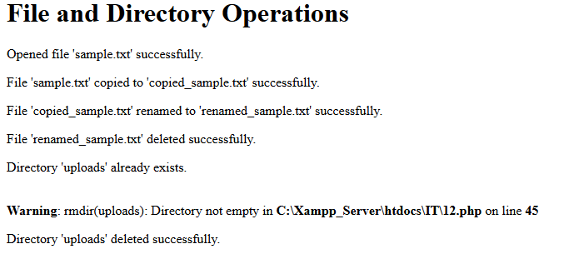

13: Write a PHP Program to Connect PHP with MySQL Database and Perform basic database operation (DML, like Insert, Delete, Update, Select)

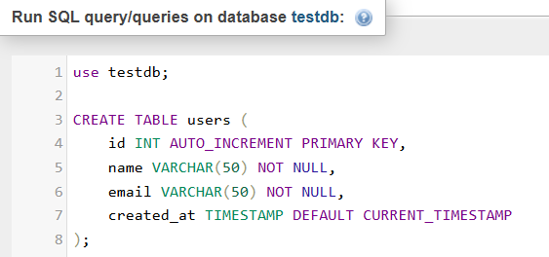

Create a PHP script (database_operations.php) that connects to MySQL, performs Insert, Delete, Update, and Select operations on the users table.

<!DOCTYPE html>

<html lang="en">

<head>

<meta charset="UTF-8">

<title>PHP MySQL Database Operations</title>

</head>

<body>

<h1>PHP MySQL Database Operations</h1>

<?php

$servername = "localhost";

$username = "root";

$password = "";

$dbname = "testdb";

$conn = new mysqli($servername, $username, $password, $dbname);

if ($conn->connect_error) {

die("Connection failed: " . $conn->connect_error);

}

echo "<p>Connected successfully to database '$dbname'.</p>";

$name = "Debasish Barman";

$email = "mail4barman@gmail.com";

$sql = "INSERT INTO users (name, email) VALUES ('$name', '$email')";

if ($conn->query($sql) === TRUE) {

echo "<p>New record created successfully.</p>";

} else {

echo "<p>Error: " . $sql . "<br>" . $conn->error . "</p>";

}

echo "<h2>Users List:</h2>";

$selectSql = "SELECT id, name, email, created_at FROM users";

$result = $conn->query($selectSql);

if ($result->num_rows > 0) {

echo "<ul>";

while ($row = $result->fetch_assoc()) {

echo "<li>ID: " . $row["id"] . " - Name: " . $row["name"] . " - Email: " . $row["email"] . " - Created At: " . $row["created_at"] . "</li>";

}

echo "</ul>";

} else {

echo "<p>No users found.</p>";

}

$updateSql = "UPDATE users SET email='mail4barman@gmail.com' WHERE name='Debasish Barman";

if ($conn->query($updateSql) === TRUE) {

echo "<p>Record updated successfully.</p>";

} else {

echo "<p>Error updating record: " . $conn->error . "</p>";

}

$deleteSql = "DELETE FROM users WHERE name='Debasish Barman";

if ($conn->query($deleteSql) === TRUE) {

echo "<p>Record deleted successfully.</p>";

} else {

echo "<p>Error deleting record: " . $conn->error . "</p>";

}

$conn->close();

?>

</body>

</html>

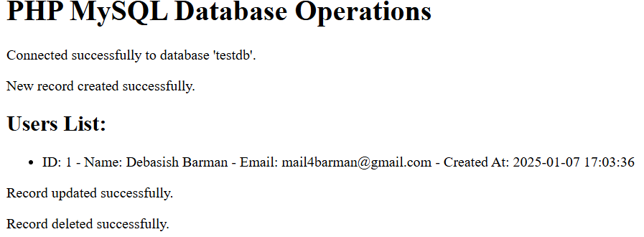

14: Write a PHP Program to demonstrate Setting query parameter, Executing query- Join (Cross joins, Inner, Outer, Self joins)

<!DOCTYPE html>

<html lang="en">

<head>

<meta charset="UTF-8">

<title>PHP SQL Joins</title>

</head>

<body>

<h1>PHP SQL Joins</h1>

<?php

$servername = "localhost";

$username = "root";

$password = "";

$dbname = "testdb";

$conn = new mysqli($servername, $username, $password, $dbname);

if ($conn->connect_error) {

die("Connection failed: " . $conn->connect_error);

}

echo "<p>Connected successfully to database '$dbname'.</p>";

$sql_create_tables = "

CREATE TABLE IF NOT EXISTS employees (

id INT AUTO_INCREMENT PRIMARY KEY,

name VARCHAR(50) NOT NULL,

department_id INT NOT NULL

);

CREATE TABLE IF NOT EXISTS departments (

id INT AUTO_INCREMENT PRIMARY KEY,

name VARCHAR(50) NOT NULL

);

INSERT INTO departments (name) VALUES

('HR'),

('IT'),

('Finance');

INSERT INTO employees (name, department_id) VALUES

('Debasish Barman', 1),

(Sayan Maity', 2),

(Srijit Bera', 1),

(Subhadeep Mondal', 3);

";

if ($conn->multi_query($sql_create_tables) === TRUE) {

echo "<p>Tables created and initial data inserted successfully.</p>";

} else {

echo "<p>Error creating tables: " . $conn->error . "</p>";

}

$conn->close();

$conn = new mysqli($servername, $username, $password, $dbname);

if ($conn->connect_error) {

die("Connection failed: " . $conn->connect_error);

}

echo "<h2>SQL Joins</h2>";

echo "<h3>Cross Join</h3>";

$sql_cross_join = "

SELECT e.name AS employee_name, d.name AS department_name

FROM employees e

CROSS JOIN departments d;

";

executeAndDisplayQuery($conn, $sql_cross_join);

echo "<h3>Inner Join</h3>";

$sql_inner_join = "

SELECT e.name AS employee_name, d.name AS department_name

FROM employees e

INNER JOIN departments d ON e.department_id = d.id;

";

executeAndDisplayQuery($conn, $sql_inner_join);

echo "<h3>Left Outer Join</h3>";

$sql_left_outer_join = "

SELECT e.name AS employee_name, d.name AS department_name

FROM employees e

LEFT JOIN departments d ON e.department_id = d.id;

";

executeAndDisplayQuery($conn, $sql_left_outer_join);

echo "<h3>Right Outer Join</h3>";

$sql_right_outer_join = "

SELECT e.name AS employee_name, d.name AS department_name

FROM employees e

RIGHT JOIN departments d ON e.department_id = d.id;

";

executeAndDisplayQuery($conn, $sql_right_outer_join);

echo "<h3>Self Join</h3>";

$sql_self_join = "

SELECT e1.name AS employee_name, e2.name AS manager_name

FROM employees e1

LEFT JOIN employees e2 ON e1.manager_id = e2.id;

";

executeAndDisplayQuery($conn, $sql_self_join);

function executeAndDisplayQuery($conn, $sql) {

$result = $conn->query($sql);

if ($result === FALSE) {

echo "<p>Error executing query: " . $conn->error . "</p>";

} else {

if ($result->num_rows > 0) {

echo "<ul>";

while ($row = $result->fetch_assoc()) {

echo "<li>" . $row["employee_name"] . " - " . $row["department_name"] . "</li>";

}

echo "</ul>";

} else {

echo "<p>No results found.</p>";

}

}

}

$conn->close();

?>

</body>

</html>

|  |  |
| --- | --- |

15: Write a PHP Program to demonstrate statement/process like exception and error, Try, catch, throw, Error tracking and debugging

PHP Program Demonstrating Exception Handling and Error Tracking

<!DOCTYPE html>

<html lang="en">

<head>

<meta charset="UTF-8">

<title>PHP Exception Handling</title>

</head>

<body>

<h1>PHP Exception Handling</h1>

<?php

function divideNumbers($numerator, $denominator)

{

if ($denominator == 0) {

throw new Exception("Division by zero error.");

}

return $numerator / $denominator;

}

try {

$result = divideNumbers(10, 0); // Intentionally set to cause an exception

echo "<p>Result of division: $result</p>";

} catch (Exception $e) {

echo "<p>Caught exception: " . $e->getMessage() . "</p>";

}

error_reporting(E_ALL);

ini_set('display_errors', 1); // Enable error display for debugging (not for production)

$array = [1, 2, 3];

$index = 5;

if (array_key_exists($index, $array)) {

$undefinedVariable = $array[$index];

var_dump($undefinedVariable);

} else {

echo "<p>Index $index does not exist in the array.</p>";

}

$logFile = "error.log";

if (is_writable(__DIR__)) {

error_log("Error: Attempted to access an undefined index in exception_handling.php", 3, $logFile);

echo "<p>Check $logFile for logged errors.</p>";

} else {

echo "<p>Unable to log errors. Ensure the directory is writable.</p>";

}

?>

</body>

</html>

